intro

Seeman 2006 NEJM review

Bone is composed of type I collagen stiffened by crystals of calcium hydroxyapatite.

Human bone is about 60 percent mineralized.

cortical bone consists of overlapping parallel osteons, the anatomical remnants of a completed remodeling event

Within a cortical bone shaft, are osteons surrounded by interstitial bone and many osteocytic lacunae distributed around the central haversian canal

Cortical bone is a complex medium, composed of two main phases: a solid part, denoted bone matrix or extra vascular matrix, and a porous part containing biological fluids, such as blood and marrow. The solid part is organized at different scales from the nanometric fundamental elements, i.e., type I collagen stiffened by crystals of calcium hydroxyapatite, through micrometer scale, i.e., lamellae (about 10 µm) until sub millimeter scale, i.e., osteon (about 0.3 mm). The latter is also known as the fundamental functional unit of cortical bone. Similarly, the porous network is also multiscale organized, from the canaliculi (about 1 µm), the lacunae containing osteocytes and (about 10 µm) to the Volkman’s and Havers’ canals, which typical sizes are about 10 and 50 µm, respectively. Moreover, unbalanced bone remodelling tends to induce resorption cavities ranging from 50 to 200 µm. Finally, cortical bone typical thickness, embedding the solid and fluid filled porous phases, typically ranges from 1 to 6 mm, depending on location, age …

The lower scales have been mainly explored on *ex vivo* extracts using different techniques such as nano indentation, synchrotron micro CT, table micro CT, scanning acoustic microscopy, … while *in vivo* measurements, such DXA, QCT, pQCT, MRI, ultrasound (up to 1 MHz), mainly focus on the mesoscale. With typical millimeter resolutions, cortical bone is thus clinically explored as an homogeneous medium. Most of the measured parameters, such as Bone Mineral Density, Index, have been successfully correlated with cortical porosity, based on different *ex vivo* validation studies.

inferring the importance of this parameter.

=> porosity index MR

=> QCT ….

ultrasound

MRI-derived porosity index (PI)

Note that recent development aims to explore cortical at a lower scale, such HR-pQCT or higher frequency ultrasound.

Improving multiscale modelisation of cortical bone could potential help to improve clinical performance of fracture evaluation.

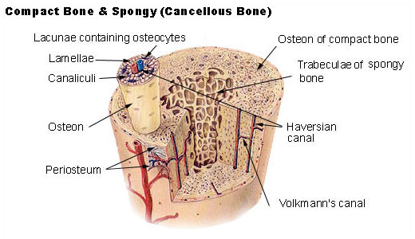

wiki